Project Name: DemoWebShop
Module: Registration / Login Page
Testing Type: Manual Testing
Webpage URL: https://demowebshop.tricentis.com/

● Scenario ID: 1a
Scenario: Verify Registration page
Test Steps:
1. Open Demo Web Shop
2. Click Register

Screenshots:
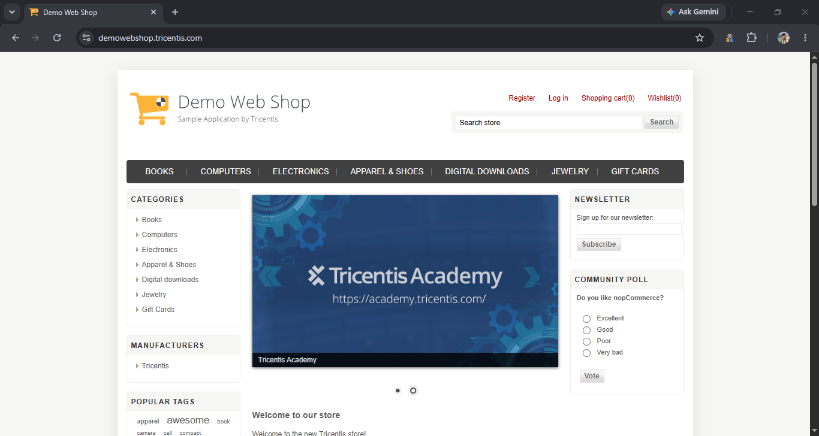

● Scenario ID: 1b
Scenario: Verify registration with valid details
Test Steps:
1. Enter valid details
2. Click Register
Screenshots:
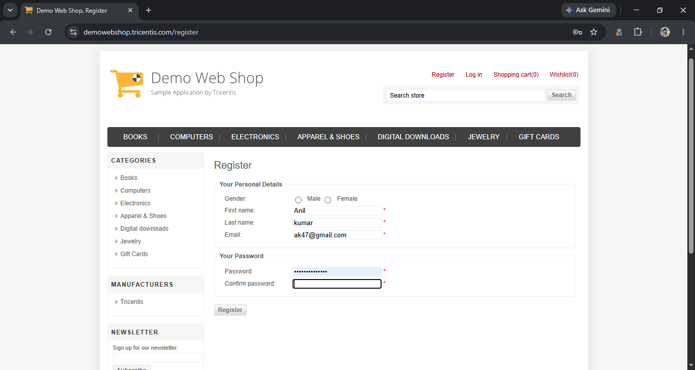

● Scenario ID: 1c
Scenario: Verify registration with all mandatory fields blank
Test Steps:
1. Leave all required fields blank
2. Click Register
Screenshots:


● Scenario ID: 2a
Scenario: Verify First Name with valid input
Test Steps:
1. Enter valid First Name
Screenshots:
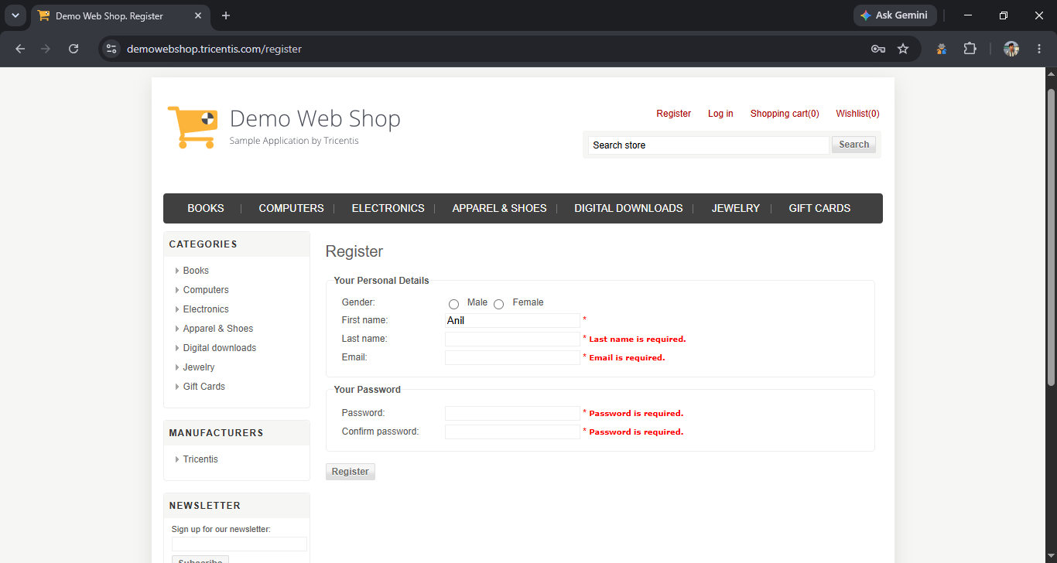

● Scenario ID: 2b
Scenario: Verify Last Name with valid input
Test Steps:
1. Enter valid Last Name
Screenshots:
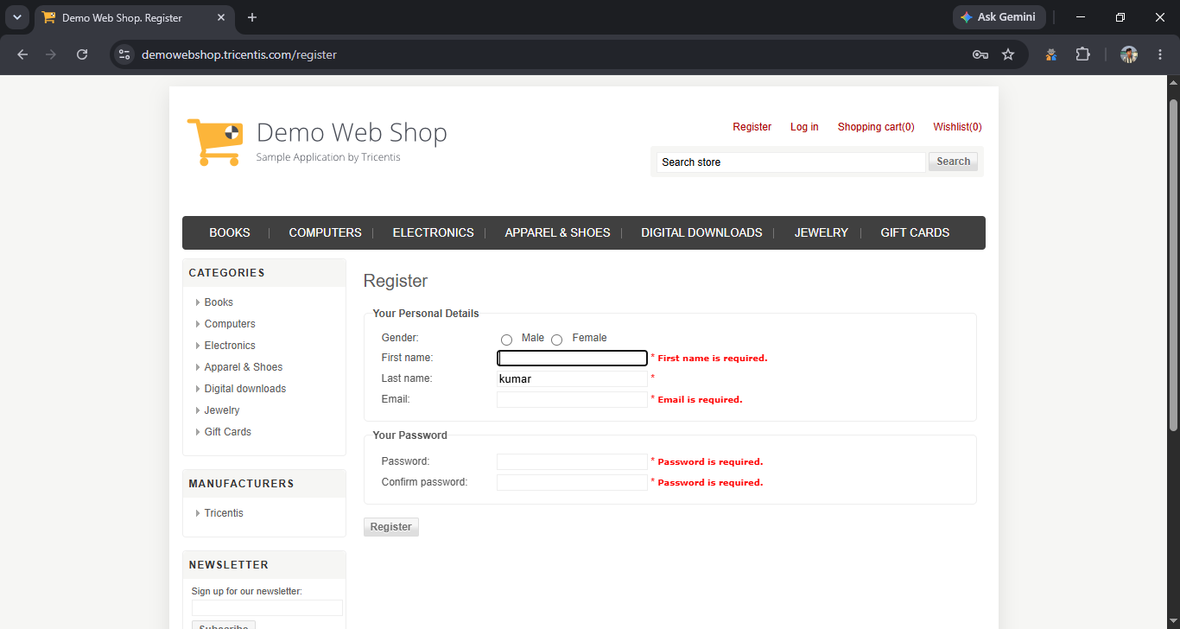

● Scenario ID: 2c
Scenario: Verify First Name with blank input
Test Steps:
1. Leave First Name blank
2. Register
Screenshots:


● Scenario ID: 2d
Scenario: Verify Last Name with blank input
Test Steps:
1. Leave Last Name blank
2. Submit
Screenshots:


● Scenario ID: 3a
Scenario: Verify Email with valid format
Test Steps:
1. Enter valid email
Screenshots:
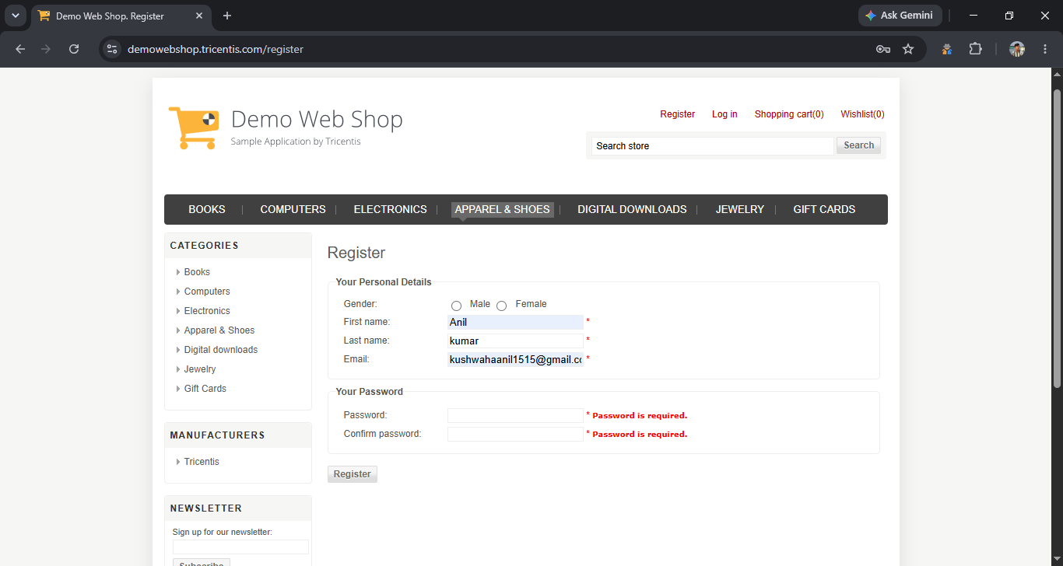

● Scenario ID: 3b
Scenario: Verify Email with invalid format
Test Steps:
1. Enter invalid email
Screenshots:
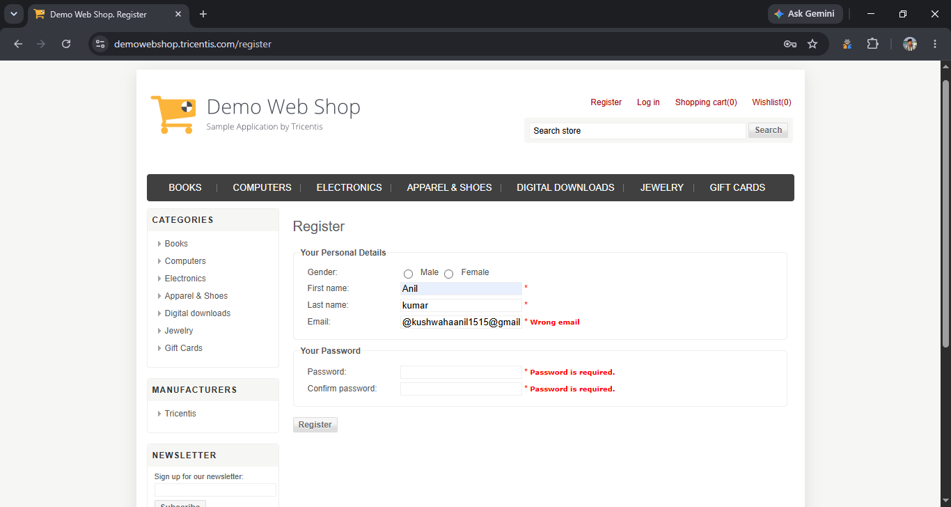

● Scenario ID: 3c
Scenario: Verify Email with blank input
Test Steps:
1. Leave Email blank
2.Submit
Screenshots:
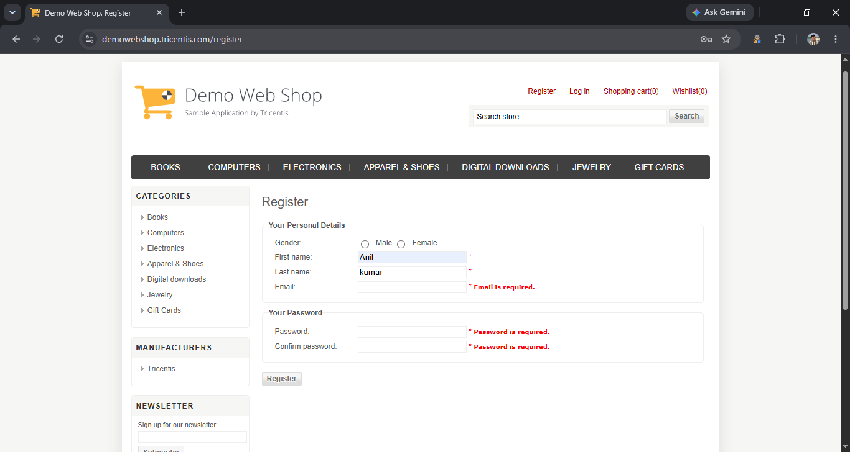

● Scenario ID: 4a
Scenario: VBVA – Password below minimum
Test Steps:
1. Enter password with one character below minimum
Screenshots:
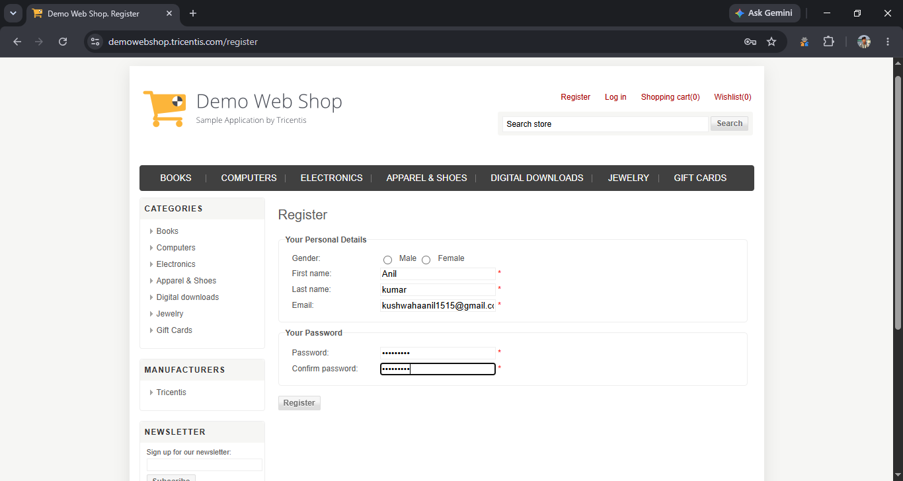

● Scenario ID: 5a
Scenario: Verify Confirm Password mismatch
Test Steps:
1. Enter different Password and Confirm Password
Screenshots:
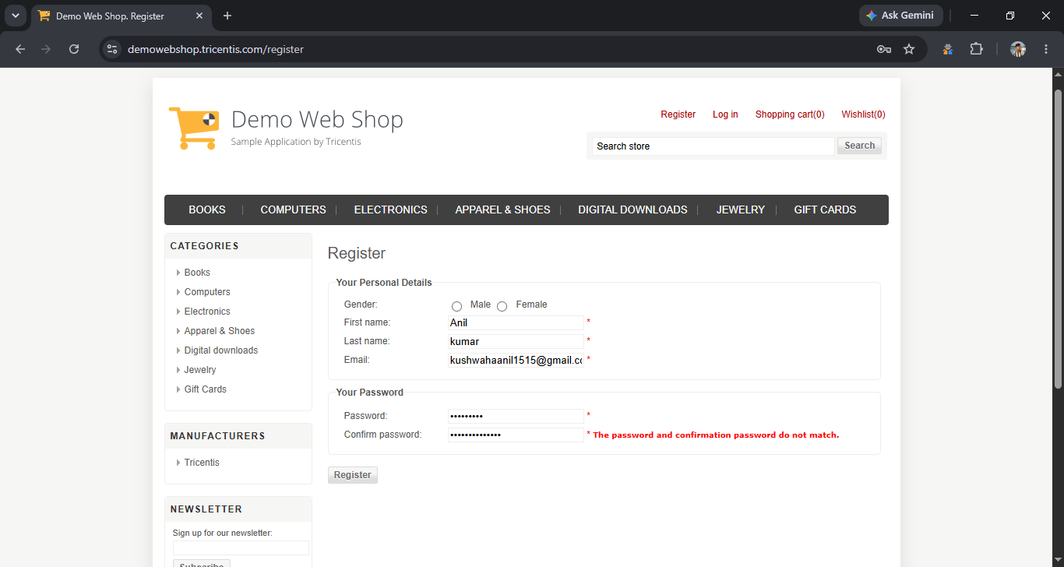

● Scenario ID: 5b
Scenario: Verify Confirm Password match
Test Steps:
1. Enter same Password and Confirm Password
Screenshots:


● Scenario ID: 6a
Scenario: Verify blank Password
Test Steps:
1. Leave Password blank
Screenshots:
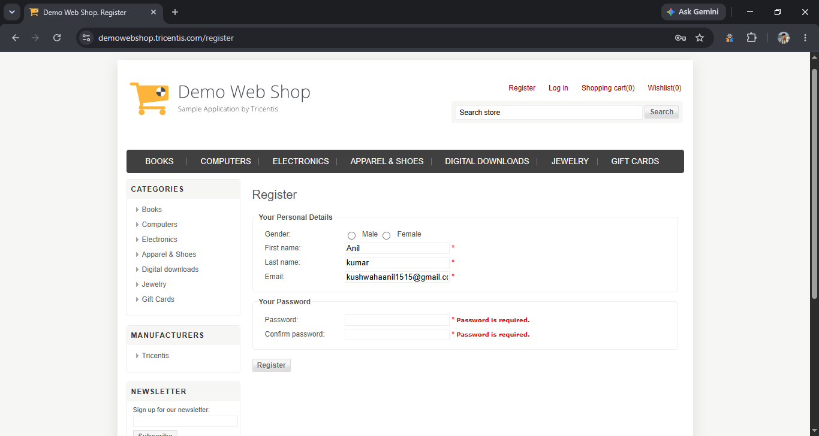

● Scenario ID: 6b
Scenario: Verify blank Confirm Password
Test Steps:
1. Leave Confirm Password blank
Screenshots:


● Scenario ID: 7a
Scenario: Verify registration using already registered email
Test Steps:
1. Enter an existing registered email
Screenshots:
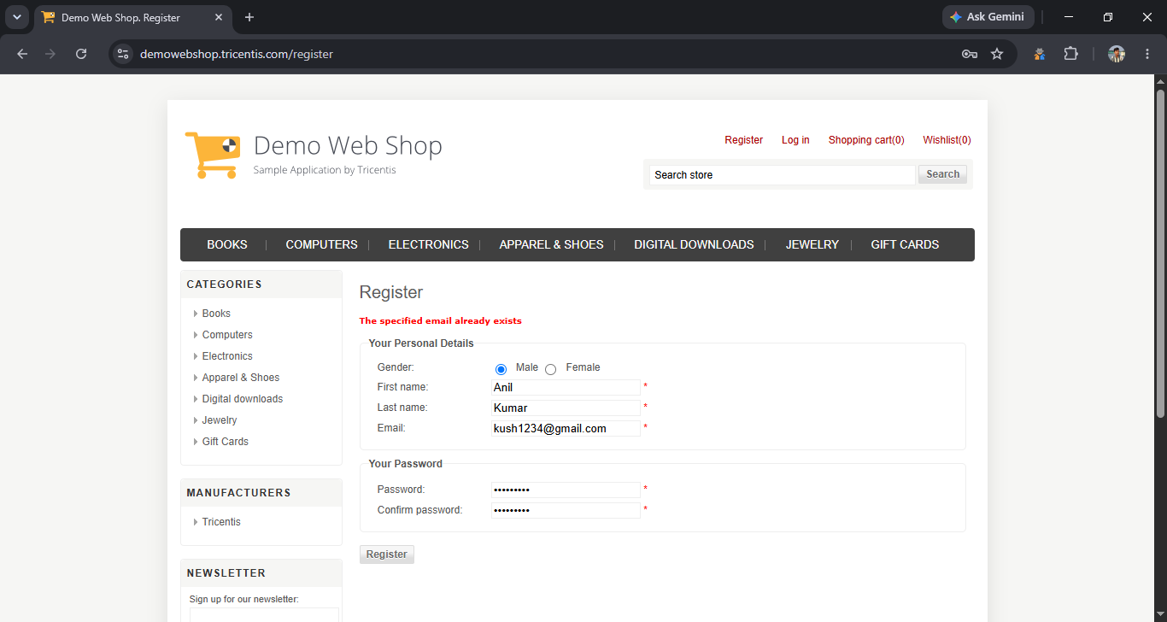

Summary of Test Results
Test Result | Count
Total Test Cases | 31
Passed | 31
Failed | 0
Blocked | 0
Pass Percentage | 100%
Fail Percentage | 0%
Defects Found | 0

Overall Result
PASS – 100%

Conclusion and Recommendations

Conclusion
The Demo Web Shop Registration and Login Modules were tested using Equivalence Partitioning and Boundary Value Analysis. Valid, invalid, blank, and boundary inputs were tested. All planned test cases passed successfully.
The testing approach reduced the number of inputs while providing effective validation coverage, which is the purpose of EP and BVA in the tutorial.

Recommendations
- Continue validating all mandatory registration fields.
- Maintain proper email-format validation.
- Maintain password and confirm-password validation.
- Continue testing boundary conditions whenever validation limits are changed.
- Perform regression testing after changes to registration or login functionality.

Bug Report
Since the report currently shows all test cases as passed, the appropriate entry is:
Field | Description
Bug ID | No Defect Found
Module | Registration / Login
Severity | —
Priority | —
Status | Closed
Description | No functional or validation defect was identified during the executed test cases.

